Clear-Com FreeSpeak II 24 and Wi-Fi

Background
The Clear-Com FreeSpeak II 2.4 GHz wireless intercom system offers unparalleled multi-channel duplex audio and radio performance for both studio and external use. With the rise in Wi-Fi and other 2.4GHz systems in use at sports and events, often provided to compliment the action on mobile devices or for remote control of lighting and score boards, how will FreeSpeakII perform in the same RF space? This paper describes the technology within FSII to provide high radio performance in dense RF fields and offers suggestions for mitigating interference during the installation.

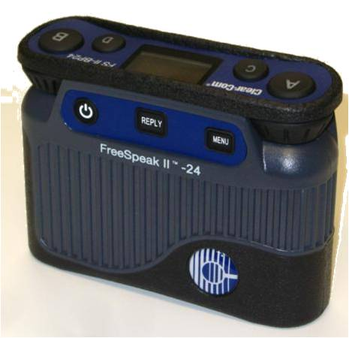
FreeSpeak II 2.4
FreeSpeak II 24 operates in the license free ISM band starting at 2.4 GHz and is the latest update to the popular FreeSpeak and Cellcom Digital Wireless system.
The new 2.4 GHz beltpacks have rugged and water resistant housing with highly improved radio performance through latest radio technology and featuring the “Clear-Com Sound” with high audio bandwidth for improved intelligibility and listening comfort.
The FSII beltpacks can either connect with the FSII-BASE Basestation or to the Eclipse-HX Delta, Median or Omega matrices fitted with the E-QUE-HX card. In each case the FreeSpeak II beltpack users can roam seamlessly between many CAT5 connected Transceiver antennas over a very wide area and still remain connected to fixed or mobile users over partylines, one to many groups or even point-to-point.
The FSII Beltpack is ideal for use in studios or control centers, outdoor production, sports, theater and for house of worship venues. The 18+ hours of battery time, rugged and strong ergonomic design with high audio bandwidth enable mobile users to communicate for long periods of time in comfort. The Beltpacks include a USB charging port for trickle charging or for continuous powered transmission.

FreeSpeak II Radio Operation
FreeSpeak II 2.4 uses Frequency Hopping Spread Spectrum (FHSS) and FreeSpeak II 2.4 hops to a new frequency for every 10 ms over 45 discrete frequency channels in the 2.4 GHz ISM band. The channels are selected based on a pseudo-random sequence and both sides of the radio system know what the sequence is.
FreeSpeak also II 2.4 also uses Adaptive Frequency Hopping which modifies the hop sequence based on the system listening for clear channels. The European Union has introduced new radio standards for equipment operating in this band in an attempt to reduce interference between equipment from different manufacturers. This European Telecommunications Standards Institute (ETSI) harmonized European standard is known as EN 300 238 v1.8.1. Thus if there is Wi-Fi in the area, the system will exclude channels that are occupied by the Wi-Fi.

Wi-Fi Radio Operation
Wi-Fi uses Direct Sequence Spread Spectrum (DSSS) for 802.11b and Orthogonal Frequency Division Multiplexing (OFDM) for the newer versions. DSSS is a wideband signal (~10MHz out of 83 MHz possible), centered on a given frequency with no hopping.
When a FreeSpeakII 2.4 radio tunes to a nearby Wi-Fi channel the intercepted energy is low in bandwidth (1MHz). Wi-Fi is spread evenly over its entire allowed bandwidth with 50mW over 10MHz, or 5mW/MHz. However, FreeSpeakII radios can cope with this power level as though it were just noise because the level is low compared to FSII’s use of GFSK (Gaussian Frequency shifted keying) modulated signal. Also as discussed, because FreeSpeak II radio is adaptively hopping, it can reject a channel if the received signal strength indicator (RSSI) is high enough.
Wi-Fi’s use of OFDM is a multi-carrier system. Each radio carrier is modulated by binary phase shift keying (BPSK). If the Wi-Fi is set to use 16 carriers it could transmit 16 bit words with a BPSK rate of 1/16. For Wi-Fi, 802.11g, the bandwidth is ~30MHz out of 83 MHz. Again if FreeSpeak II radio “hops” to one of these carriers, it would lose only one 10ms chunk of information because it would then “hop” to another channel for the next chunk of information. FreeSpeak II radios will work to reject a channel if the RSSI is high enough, at least for some specific time. OFDM is low power on a given channel compared to our modulated signal so we likely will not even lose packets.
FreeSpeak II Radio Adaptive Exclusion Process; The process of deciding which channels should be used is a three-stage process. The process includes scanning for occupied channels, broadcast of a channel exclusion list and use of the exclusion list. The process is done in three steps coexisting in time. In Figure 1, the process is shown in time. The system first performs a channel scan to determine occupied channels. This list is then broadcast to the belt packs. The beltpacks and transceivers will use this list during period 3. The process is continuous, and as is illustrated in Figure 1 the list could be constantly changing.

Time
1 | 2 | 3 | 4 | 5 | 6 | 7 | 8
Scan | Broadcast | Use
 | Scan | Broadcast | Use
 |  | Scan | Broadcast | Use
 |  |  | Scan | Broadcast | Use
 |  |  |  | Scan | Broadcast | Use
 |  |  |  |  | Scan | Broadcast | Use

Figure 1: The Channel Adaptive Exclusion Process

Depending on the radio environment, a maximum of 45 and minimum of 15 channels may be used by the FSII system at any time.

General Interference Mitigation
So although FSII contains technology to give best radio performance and to avoid other radio systems there are certain mitigating installation techniques that can be used in an attempt to prevent interference between different equipment in the 2.4 GHz spectrum.
Some of these are:
- Physical separation. If possible, equipment operating in the 2.4 GHz spectrum should be operating as far as physically possible from the FSII Transceiver. A Wi-Fi access point or router is a common piece of equipment that could interfere with the FSII system, or vice versa. These two pieces of equipment in particular should not be located closer than 6 feet, (2m).

- Spectral separation. Most Wi-Fi access points allow the administrator to set the channel and bandwidth that system operates on. Some systems employ an ‘auto’ mode, in which the Wi-Fi access point will automatically selected the channel. With Wi-Fi access points, it is sometimes advantageous to manually select a channel number to keep the Wi-Fi transmission at a fixed carrier location.

- Spectral efficiency. Wi-Fi systems employ a standard sometimes referred to as 802.11. 802.11 is simply the number given to the standard by the Institute of Electrical and Electronics Engineers (the IEEE). Modern Wi-Fi routers will allow operation employing the 802.11n mode. This mode will allow higher data rates, but it also may consume twice the number of radio channels. If the Wi-Fi router is set to 802.11n mode, it would be best to limit Wi-Fi bandwidth to 20 MHz. Figure 2 gives examples of Wireless LANs set to provide non-overlapping channels that can be dedicated to separate Wi-Fi and FSII operations.

- Alternate band selection. While most Wi-Fi systems operate at 2.4 GHz, which is the same band as the FSII system, most allow operation at 5 GHz. If possible, move any Wi-Fi access points and equipment to 5 GHz. This of course requires all Wi-Fi equipment to be 5 GHz capable, and most older equipment may only allow 2.4 GHz operation. Selection of 5 GHz may also not be desirable if the Wi-Fi network is for customer access.

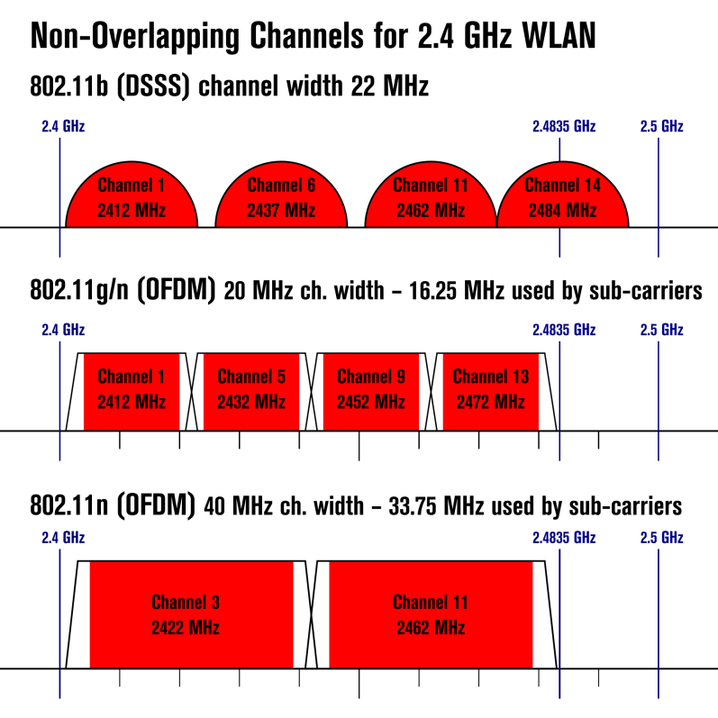
Figure 2: Non-overlapping Wi-Fi Channels

FreeSpeak II User densities
FreeSpeak II 2.4 (FSII-24) and its alternate band FreeSpeak II 1.9 (FSII-19) work cooperatively in the same radio space. FSII-24 can provide duplex communications with up to 4 beltpacks per transceiver antenna. Up to 10 transceiver antennas can be connected to one FreeSpeak II base or matrix card (E-QUE-HX). Similarly FSII-19 (1.9 GHz DECT operation) can provide duplex communications with up to 5 beltpacks per transceiver antenna. Up to 10 transceiver antennas can be connected to one FreeSpeak II base or matrix card (E-QUE-HX). A base or matrix card can mix 2.4 and 1.9 transceivers to a total of 10.
If one space needs more than 4 or 5 beltpack users you can add adjacent transceivers. We recommend the transceivers are no closer than 2 feet apart.
In the US up to 25 FSII-19 and 40 FSII-24 beltpacks can be co-located in the same radio space in good conditions. In the rest of the world, where allowed, up to 50 FSII-19 and 40 FSII-24 beltpacks can be co-located in the same radio space in good conditions.
So in the same radio space, more than one base station may operate so long as the total quantity of 1.9 GHz beltpacks does not exceed 25 (US) or 50 worldwide together with up to 40 2.4GHz beltpacks. Beltpacks registered with one base will not communicate with another base and will work until the radio space is full.

FreeSpeak II Radio Specifications
Radio Frequency Range: 2400 – 2483.5 MHz  Type: | 2400 – 2483.5 MHz  Frequency Hopping, Spread Spectrum (FHSS)
Transmit Power: | 100mW burst
Modulation Type: | Gaussian filtered GFSK, TDMA
TDMA Frame: | 10 ms
Frequency Stability: | 13 ppm
Harmonics/Spurious: | Exceeds FCC and ETSI specifications over temperature range

More information at http://www.clearcom.com/product/wireless/freespeakII

Glossary

TERM | DESCRIPTION
ISM Band | The industrial, scientific and medical (ISM) radio bands are radio bands(radio frequencies) reserved internationally for the use of radio frequency (RF) energy for industrial, scientific and medical purposes other than telecommunications.
BPSK | Binary phase-shift keying (BPSK) is a digital modulation scheme that conveys data by changing, or modulating, the phase of a reference signal. It uses two phases which are separated by 180°.
GFSK | Gaussian frequency-shift keying (GFSK) is a type of frequency shift keying modulation that uses a Gaussian filter to smooth positive/negative frequency deviations.
FHSS | Frequency Hopping Spread Spectrum (FHSS) is a method of transmitting radio signals by rapidly switching a carrier among many frequency channels, using a pseudorandom sequence known to both transmitter and receiver.
DSSS | Direct-sequence spread spectrum (DSSS) is a spread spectrum modulation technique. Spread spectrum systems are such that they transmit the message bearing signals using a bandwidth that is in excess of the bandwidth that is actually needed by the message signal.
Wi-Fi | Wi-Fi is the name of a popular wireless networking technology that uses radio waves to provide wireless high-speed Internet and network connections. It is trade mark name for products that conform to IEEE 802.11x standards.
IEEE | The Institute of Electrical and Electronics Engineers, professional organization, that sets product standards, to assure interoperability.
OFDM | Orthogonal frequency-division multiplexing (OFDM) is a method of encoding digital data on multiple carrier frequencies.
TDMA | Time division multiple access (TDMA) is a channel access method for shared medium networks. It allows several users to share the same frequency channel by dividing the signal into different time slots.
FCC | Federal Communications Commission (FCC) regulates interstate and international communications by radio, television, wire, satellite and cable.
ETSI | European Telecommunications Standards Institute (ETSI) is an independent, not-for-profit, standardization organization in the telecommunications industry.
WLAN | Wireless local area network (WLAN) is a wireless computer network that links two or more devices using a wireless distribution method.

